meshmixer manual
This manual is a work-in-progress. Please bear with us =)
Get the latest version here: http://meshmixer.com/help/

Contents:
UI Overview
Importing/Loading Files
hotkey quick reference
Tool Documentation:
- Drop Part Tool
- Smooth Brush Tool
- Selection Tool
- Smooth Tool
- Smooth Boundary Tool
- Extrude Tool
- Volume Brush Tool
Workflows:
- Extrusion Workflow
- Smoothing Workflow
- Collar Workflow

UI Overview
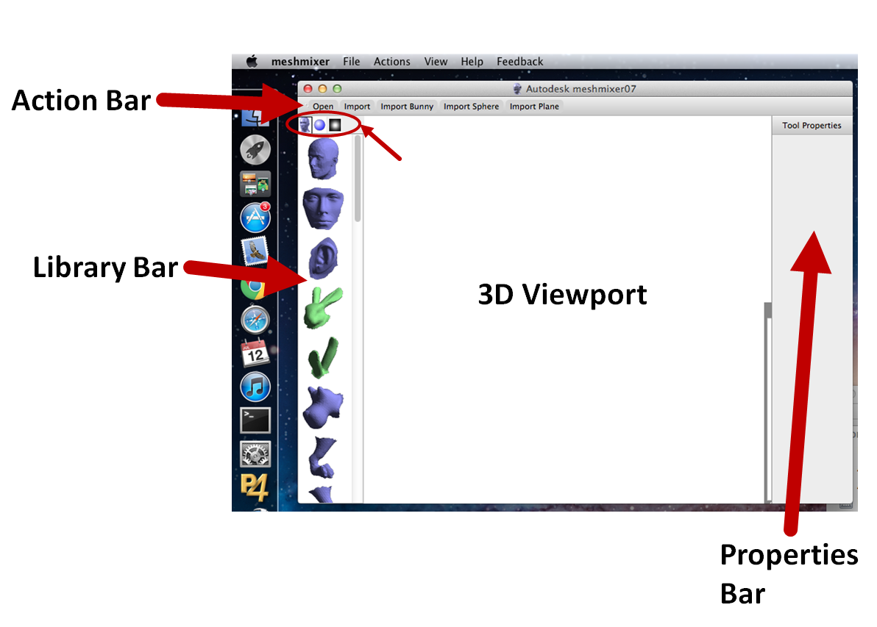
A key concept to understand in meshmixer is the Action Bar. The Action Bar is not a traditional menu, it is a dynamic context-sensitive menu that responds to the current scene.
For example, before you have loaded any objects into meshmixer, the Action Bar will provide you with commands such as Open, Import, etc. Once you load an object, those items will no longer be accessible from the Action Bar, you will have to use the File menu in the standard system menu (attached to the window on Windows, at the top of the screen on Mac OS X).
The Action Bar may change depending on the Tool you have selected. If ever you want to get back to the initial Action Bar state, just keep hitting Escape.

Importing/Loading Files
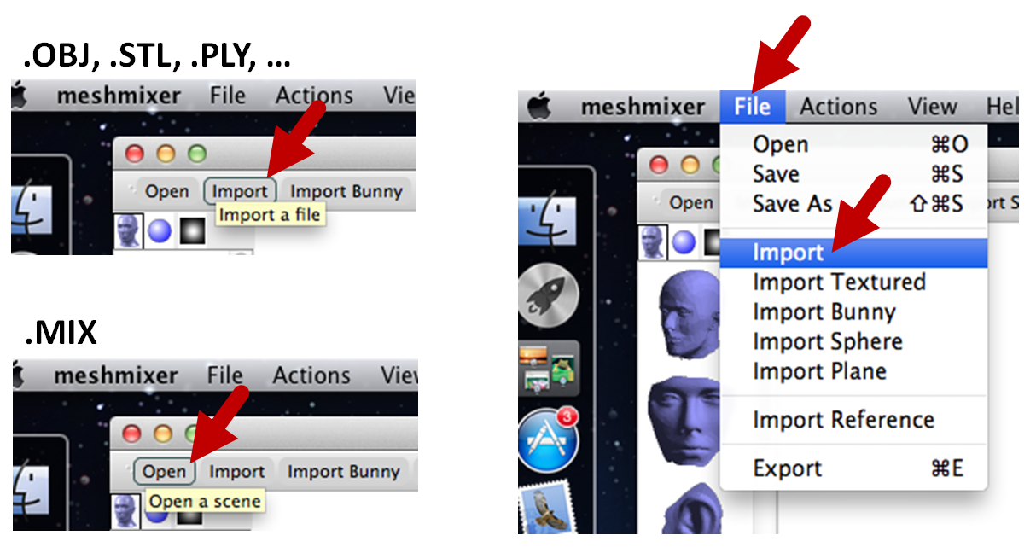
To bring an external mesh into meshmixer (.OBJ, .STL, .PLY), use the Import command in either the Action Bar or the File menu. This will load a mesh into the current scene.
If the scene already contains objects, you will be asked whether you want to Replace the existing objects, or Append to them (creating an additional object in the scene).
You can save your scene as a .MIX file using the Save and Save As commands. MIX is meshmixer’s native format, and is the most effective for storing data if you want to load it back into meshmixer later, using the Open command. However, keep in mind that no other software supports .MIX, so you still may need to use the Export command to create an OBJ or STL file.
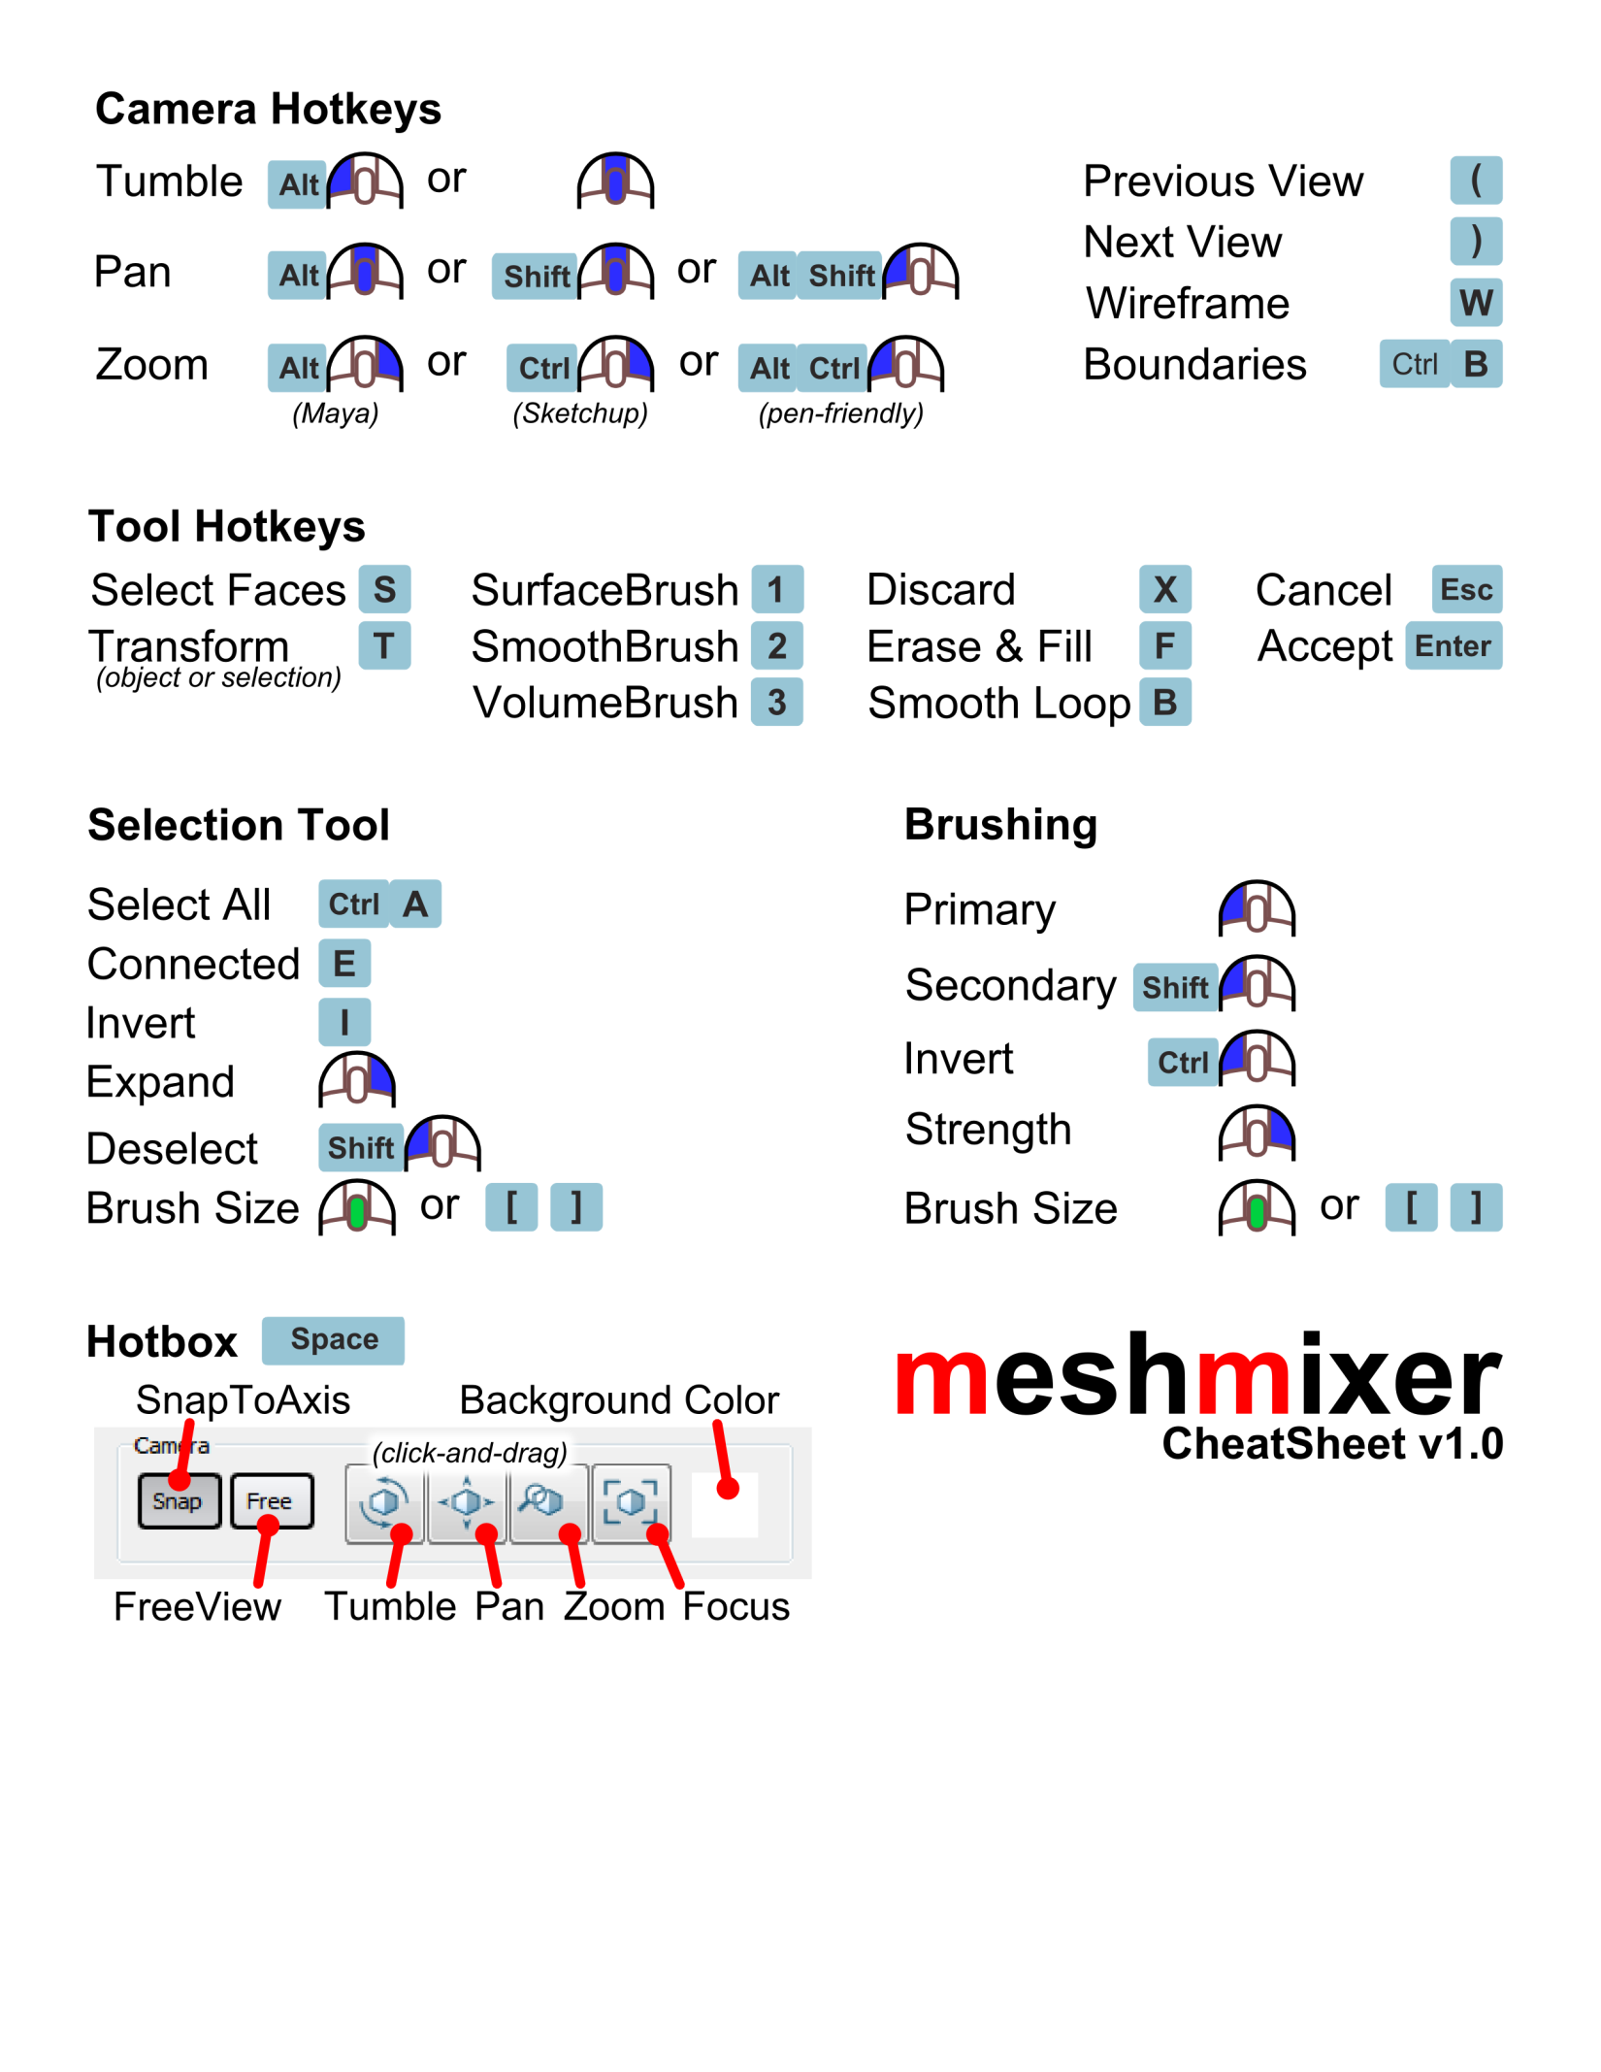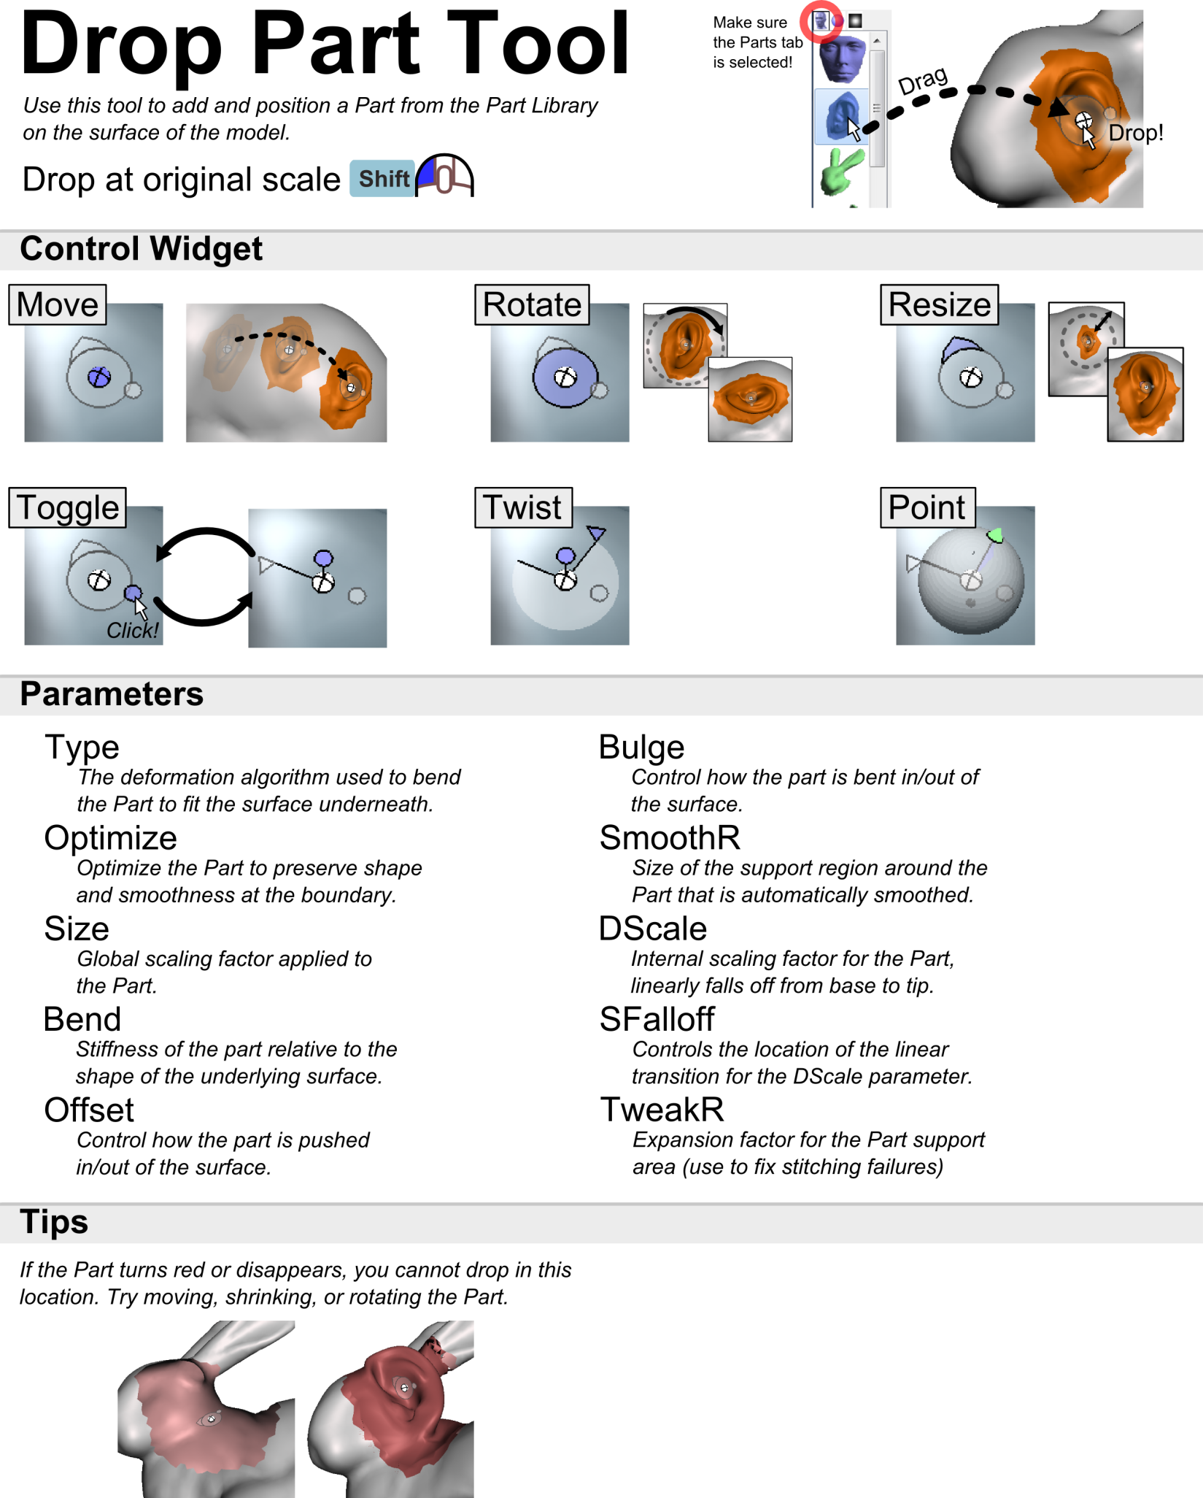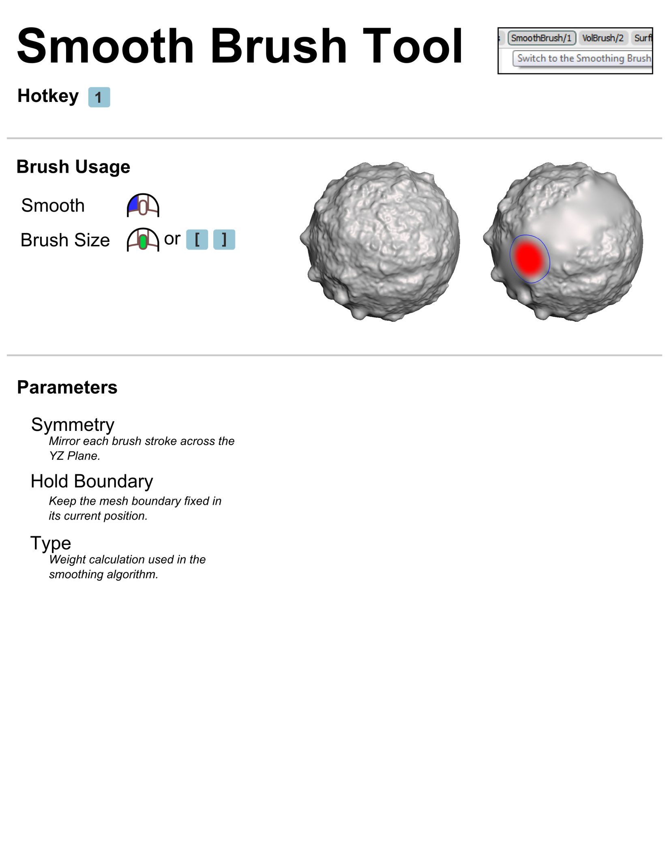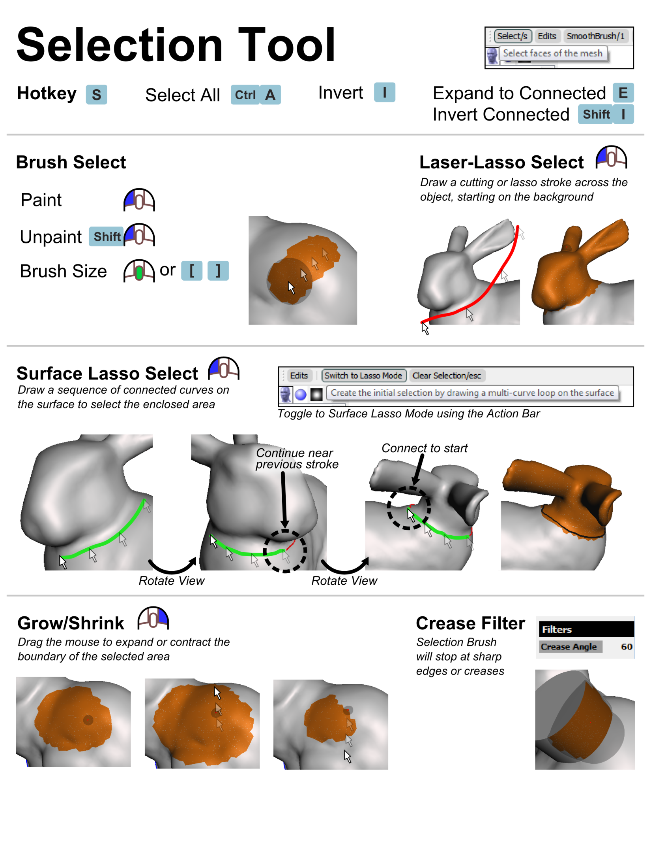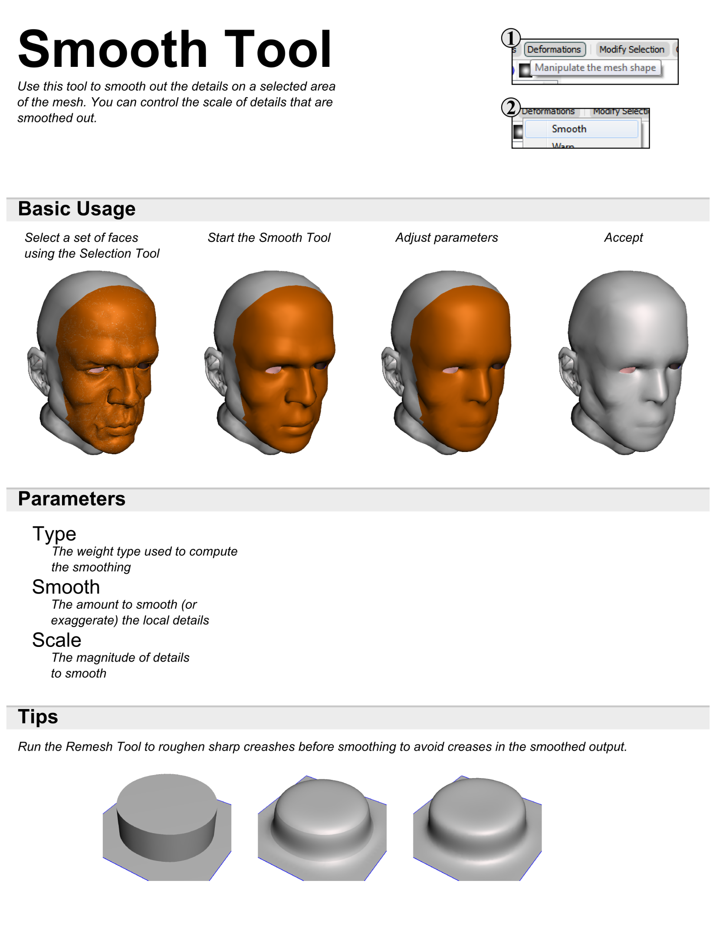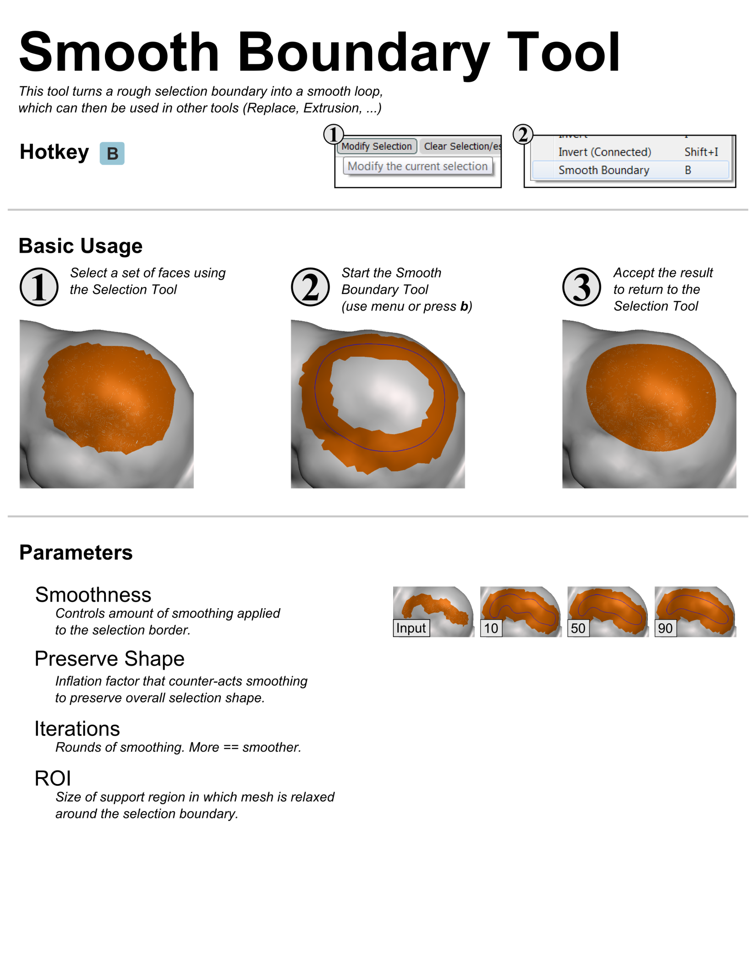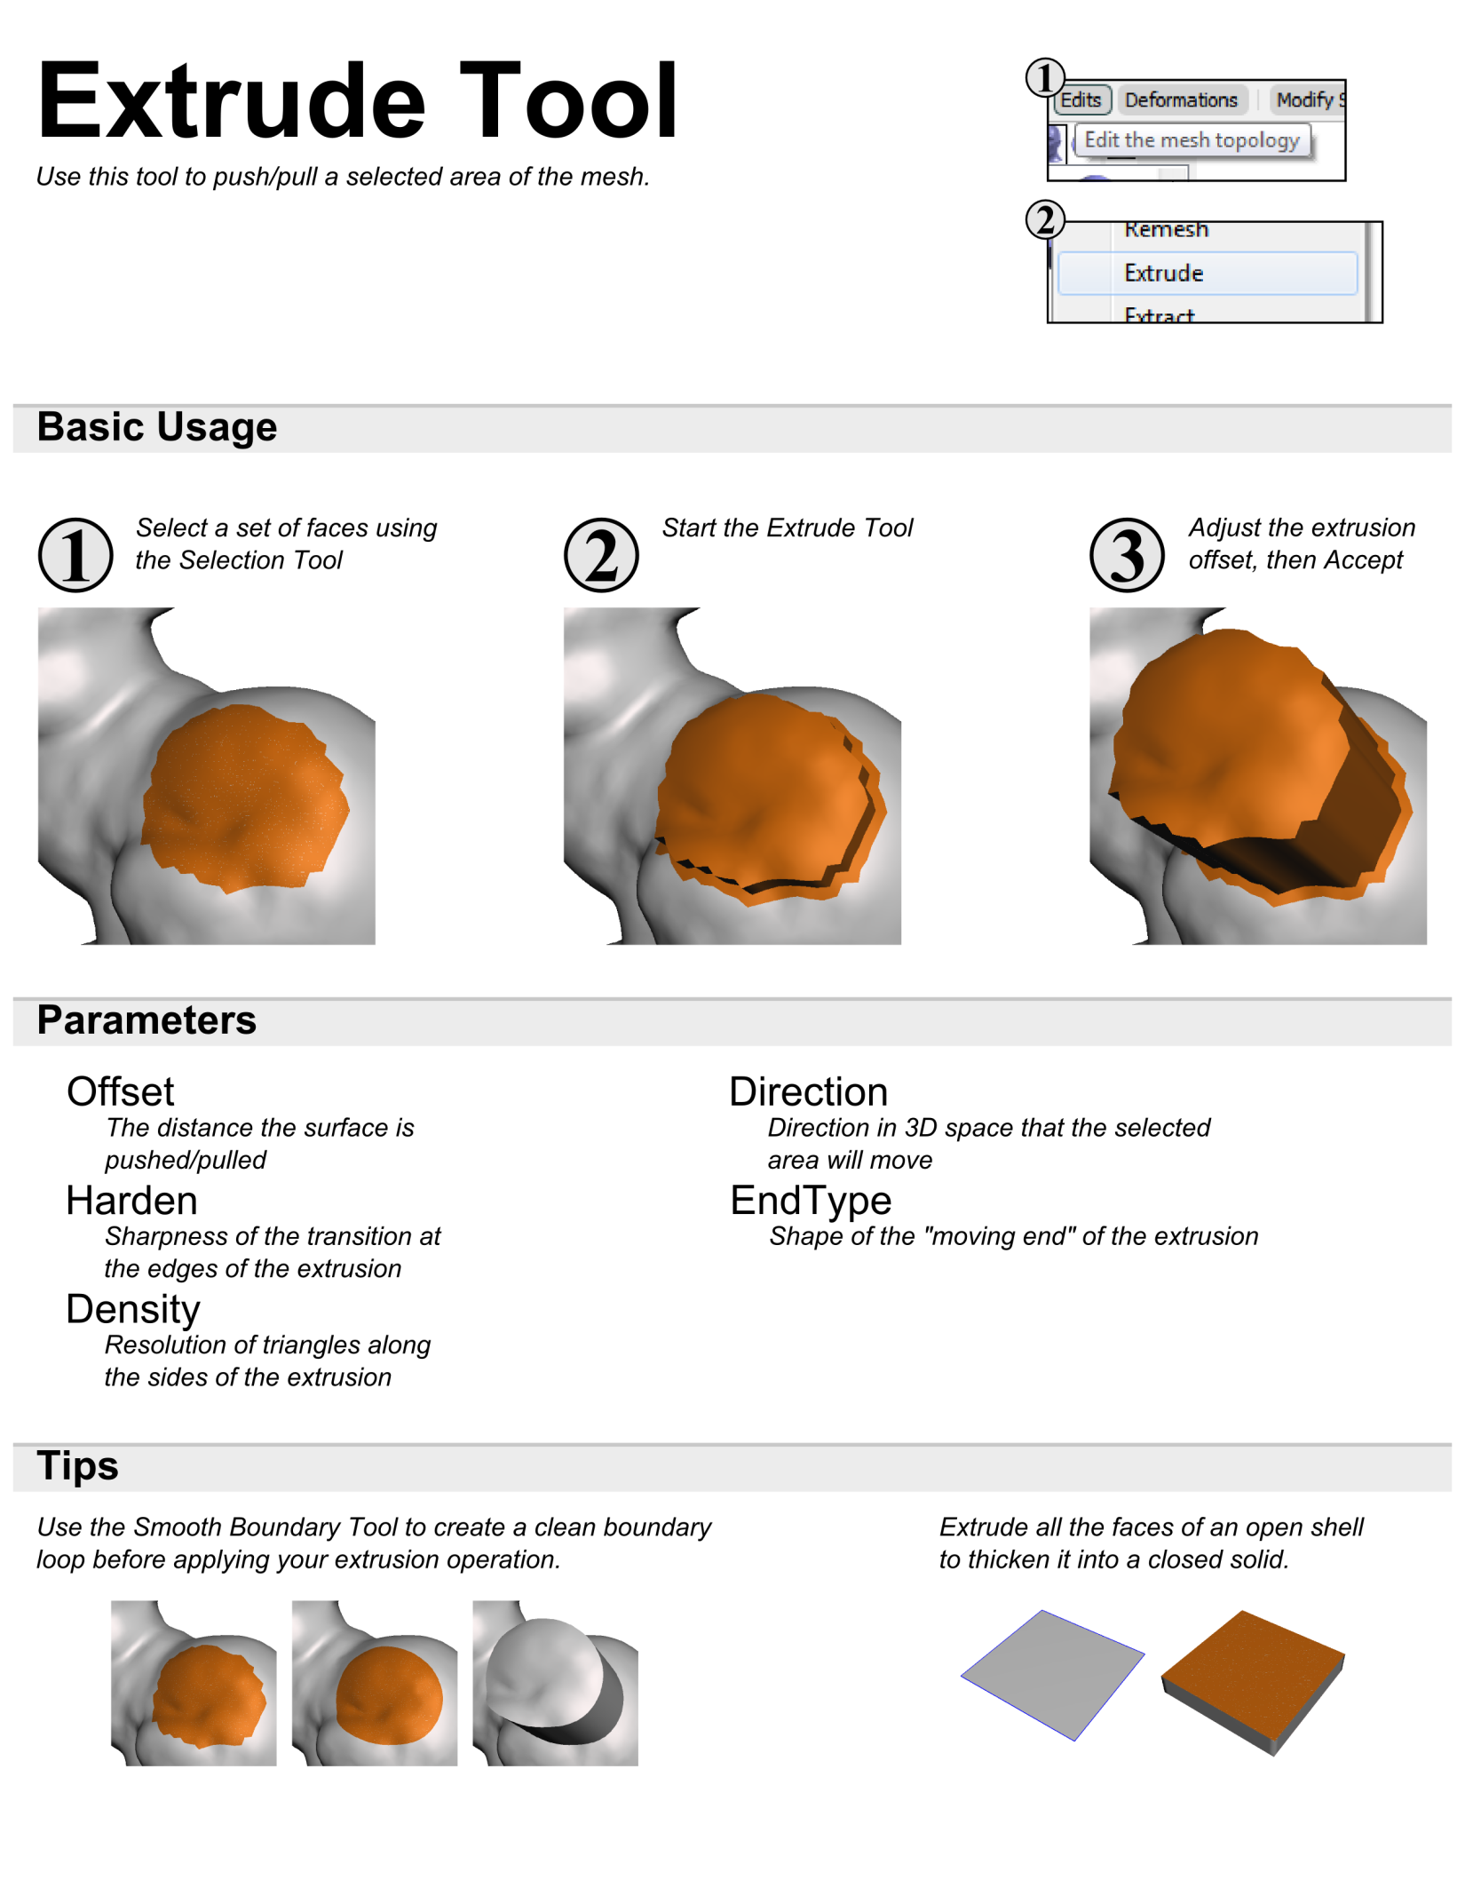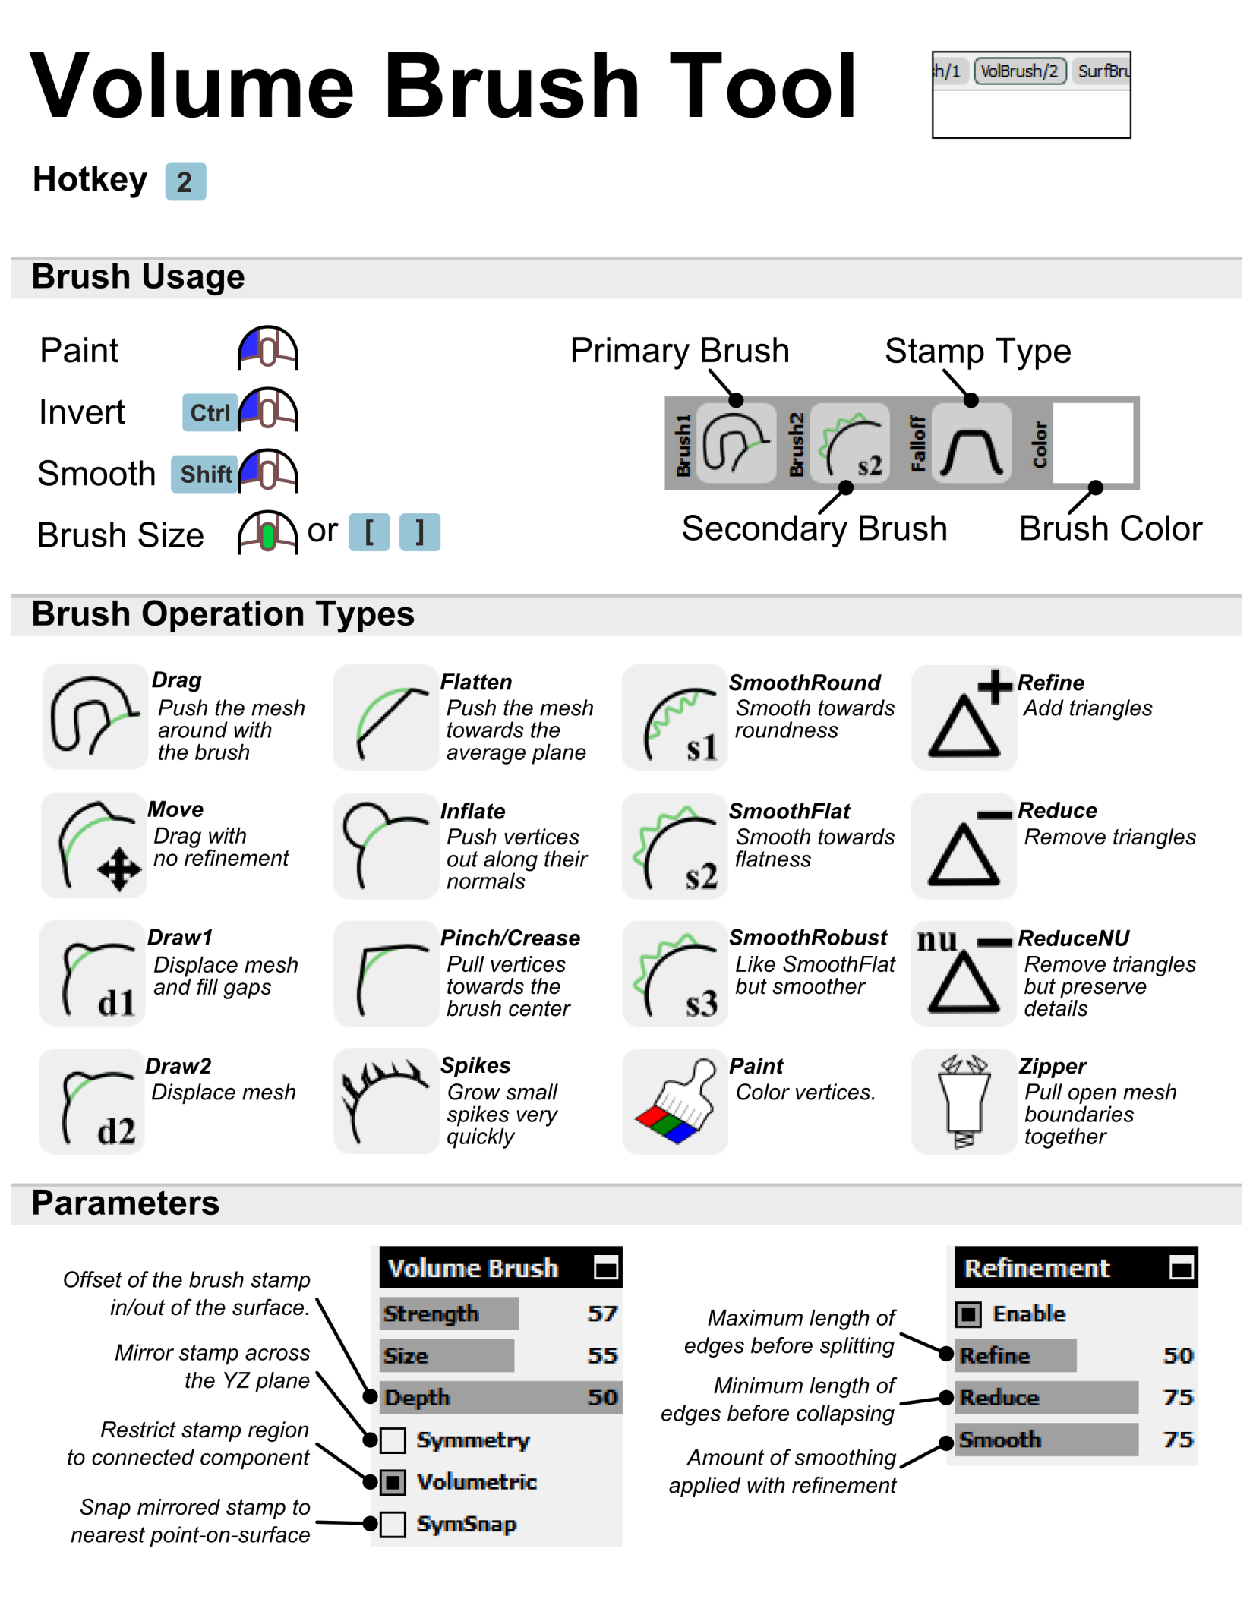

Extrusion Workflow
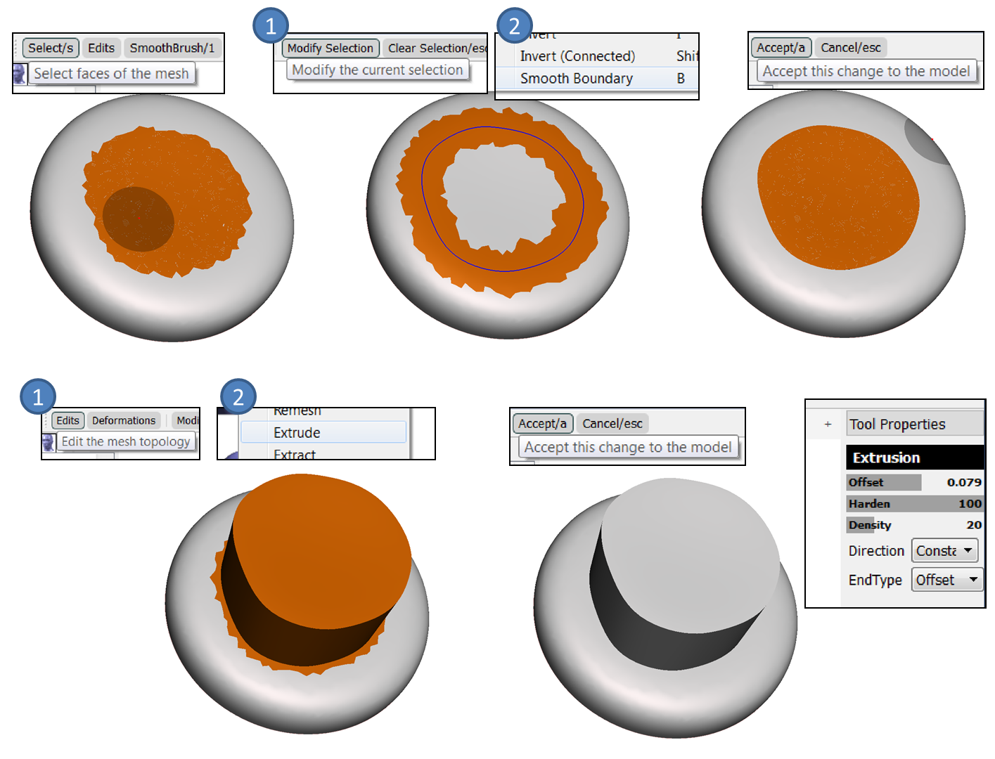

Smoothing Workflow
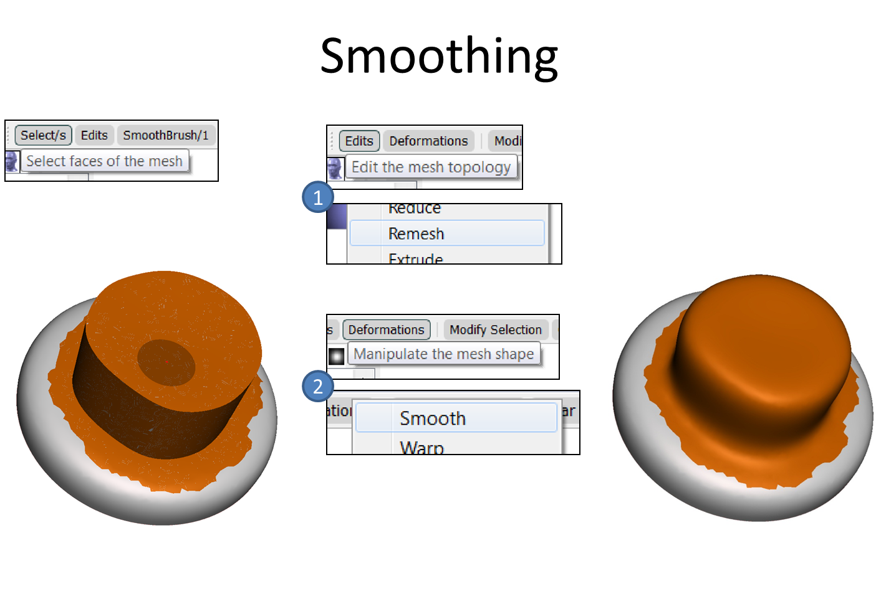

Collar Workflow
